D. A. V. P. S. DARBHANGA

# SUMMAR VACATION HOLIDAY ASSIGNMENT AND PROJECT

(2025-2026)

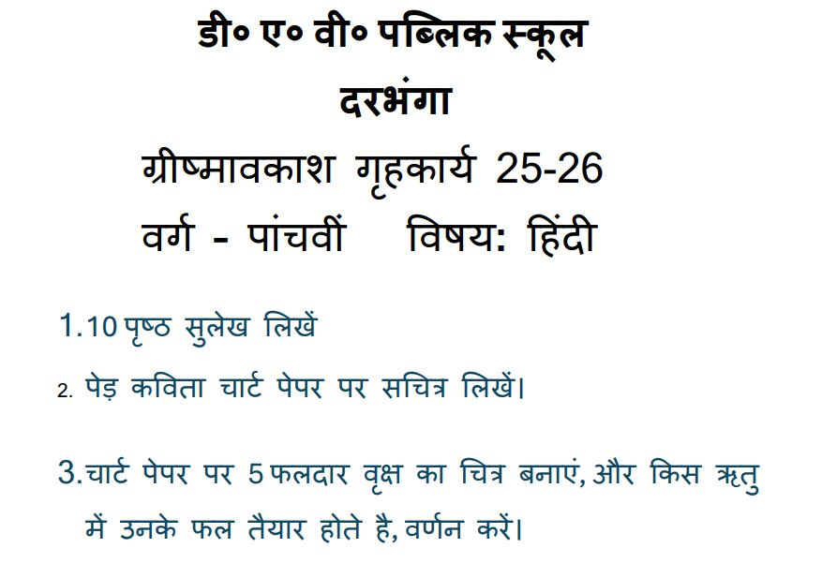

SUMMER VACATION HOME WORK

Class :- V

Sub :- Science

Assignment :- Write questions and answers of chapter 01 and 02 in a separate holiday Homework copy.

Project :- Draw a well labelled diagram of the inner view of the human eye and Breathing system.

SUMMER VACATION

ASSIGNMENT AND PROJECT

Class - V

Subject – ICT(COMPUTER)

i. Draw a model on chart paper showing means of ICT.

ii. Draw all components of CPU ( ALU , MU & CU).

SUMMER VACATION

ASSIGNMENT AND PROJECT

Class - V

Subject - Mathematics

Assignment - Brain Teaser of chapter - 1 and 2

Project - Colour prime numbers and composite numbers from 1 to 100 on chart paper.

SUMMER VACATION HOLIDAY HOMEWORK

Subject - English

Class - 5

Q. Verb forms :- A PDF is to be created and sent in the groups of the classes . ( Chart paper) .

Q. Application writing.

Q. Paragraph writing / write and learn a paragraph in 100-120 words on the topic' Books are our best friends'.

Q. Write and learn the questions and answers of the lessons taught in class .

